NAME: KARIUKI LISPER WAIGUMO

REG NO: BSCCS/2024/60096

COURSE/CLASS: BACHELORS OF SCIENCE IN COMPUTER SCIENCE

UNIT CODE: BIT3208

UNIT NAME: ADVANCED WEB DESIGN AND DEVELOPMENT

LECTURERER NAME: MICHAEL NYORO

SEMESTER/ ACADEMIC YEAR: SEMESTER 6

PROJECT DETAILS

PROJECT TITLE: LISPER/CHUM STORE

SELECTED TECHNOLOGIES: 1. PHP & SQL

GITHUB REPOSITORY LINK:

Upload files · risperkariuki068-png/Chum-Lisper-Store

TABLE OF CONTENTS

Table of Contents
WEEK 1: LOCAL ENVIRONMENT SETUP 3
Title: Installation and Testing of Local Development Environment 3
Fig 1: XAMPP 3
Fig 2: Apache and MySQL Running (Screenshot from XAMPP Control Panel) 4
Fig 3: Localhost Test page (Screenshot browser running localhost) 4
Fig 4: Hello World Test (Screenshot of first PHP or HTML page) 5
Figure 5: Database Connection Test (screenshot showing successful DB connection) 5
WEEK 2: Wireframes and GUI Design 6
Title: User Interface Planning and System Design 6
Fig 1: Hand- Drawn Wireframe 6
Fig 2: Dashboard Layout Design 7
Figure 3: Mobile View Mockup 8
Fig 4: Color Theme and Navigation Structure 9
Fig 5: GUI prototype in Figma/ Canva/ Draw.io 10
Week 3: JavaScript and PHP Basics 11
Title: Frontend Interaction and Backend Foundations 11
Fig 1: JavaScript Form Validation 11
Fig 2: Password Strength Checker 12
Fig 3: PHP Syntax Practice 13
Fig 4: Database Connection Script 13
Fig 5: Dynamic User Input Handling 14
Week 4: Dynamic Backend Processing, Authentication and Session Management 15
Title: System Implementation Summary 15
Fig 1: Login System Development 15
Fig 2: Login Page Interface 16
Fig 3: Database Connection Script 17
Fig 4: Users table in phpMyAdmin 17
Fig 5: Session Management 18
Week 5: Building Data-Driven Systems using Databases 19
Task 1: Introduction to Databases 19
Fig 1: Php showing the database successfully created. 19
Fig 2: Table Creation for users with ID, Username, and password fields 19
Fig 3: Insert Query adding a new customer 20
Fig 4: View records query displaying stored data 21
Fig 5: Edit query Updating User Information 22
Fig 6: Delete Query Removing a record successfully (codes) 23

WEEK 1: LOCAL ENVIRONMENT SETUP

Title: Installation and Testing of Local Development Environment

Fig 1: XAMPP
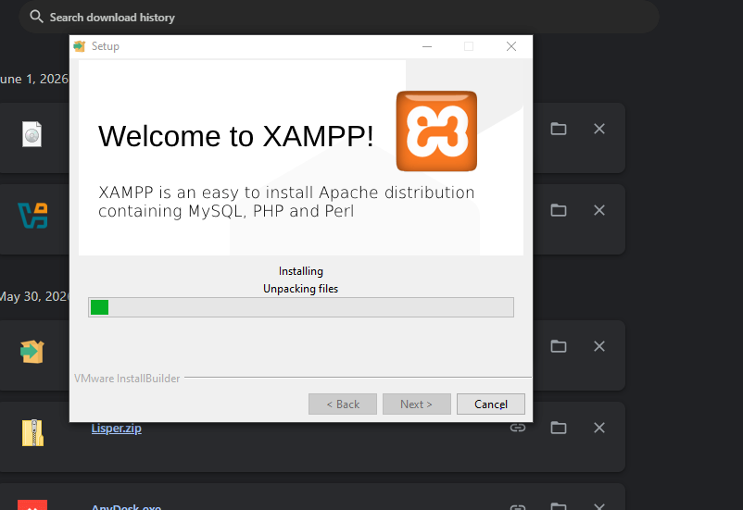

Fig 2: Apache and MySQL Running (Screenshot from XAMPP Control Panel)
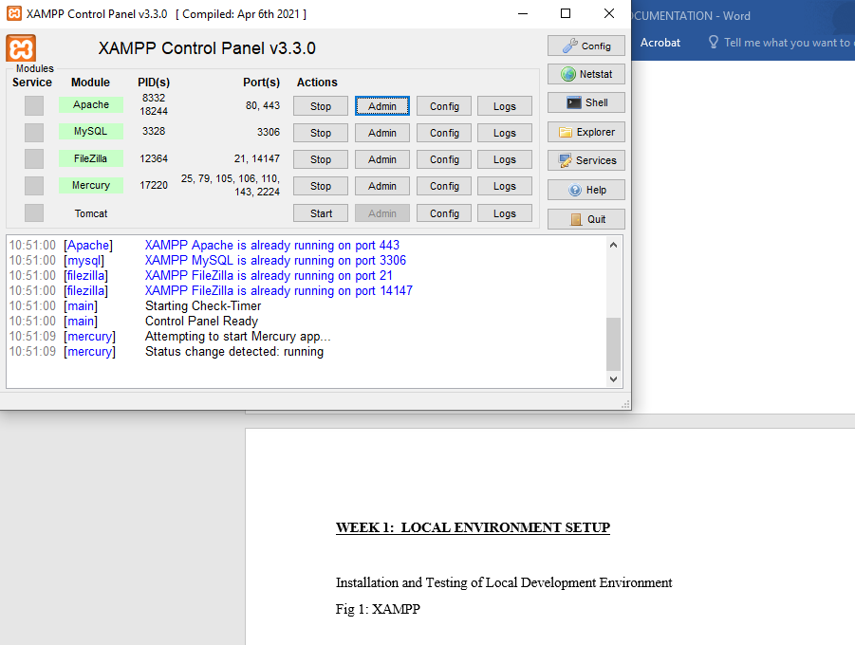

Fig 3: Localhost Test page (Screenshot browser running localhost)
I’m using fire fox to run the localhost.

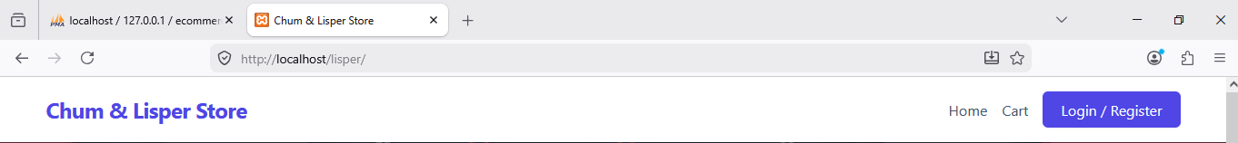

Fig 4: Hello World Test (Screenshot of first PHP or HTML page)
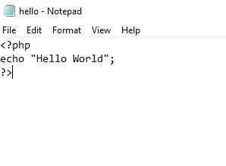

Figure 5: Database Connection Test (screenshot showing successful DB connection)
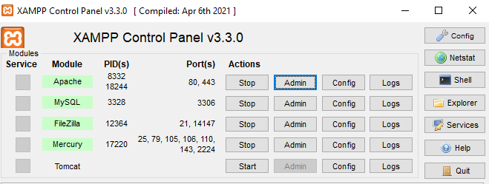
Reflection: Figure 5 shows the successful connection between PHP and MySQL. This confirms that Apache and MySQL services were properly configured in XAMPP.

WEEK 2: Wireframes and GUI Design

Title: User Interface Planning and System Design

Fig 1: Hand- Drawn Wireframe
(Login/Homepage)
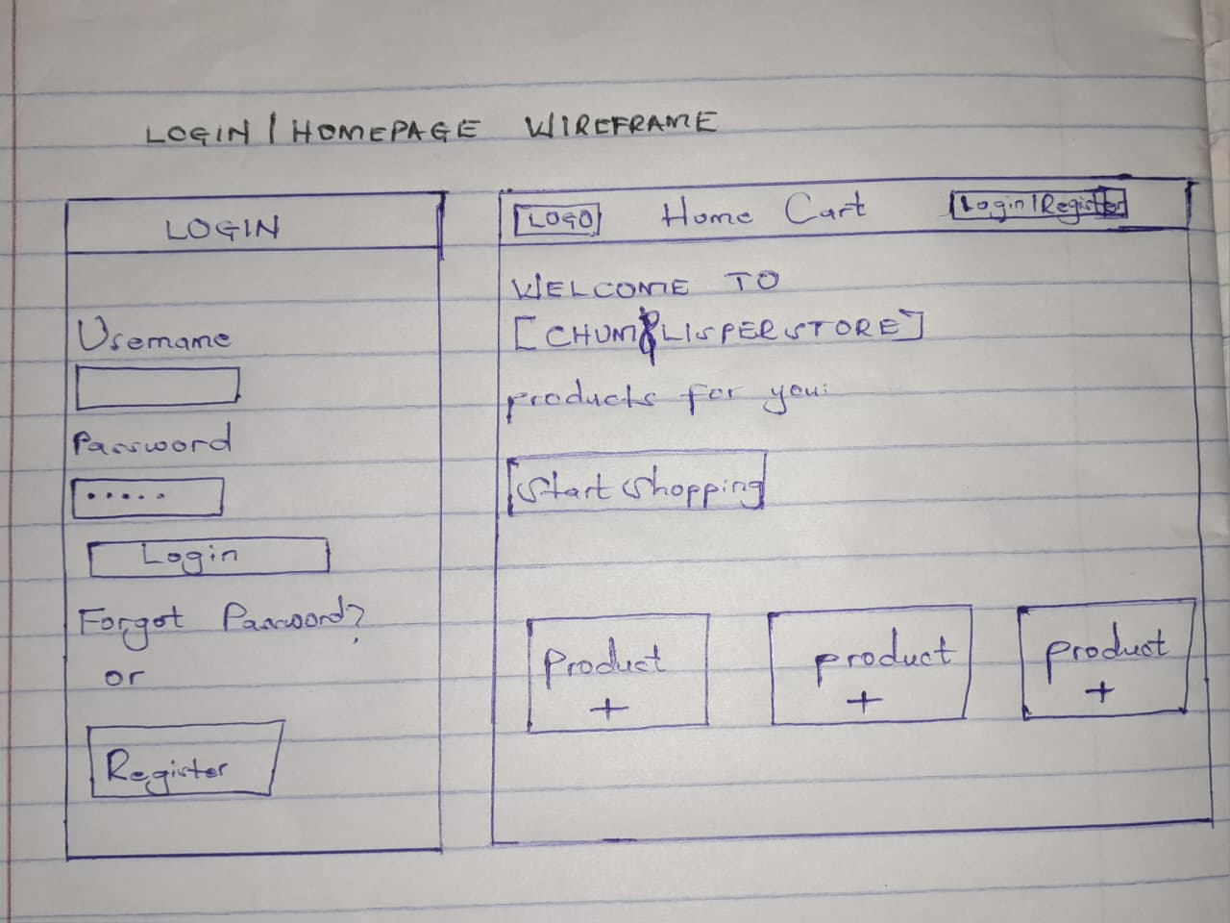

Fig 2: Dashboard Layout Design


Figure 3: Mobile View Mockup


Fig 4: Color Theme and Navigation Structure


Fig 5: GUI prototype in Figma/ Canva/ Draw.io
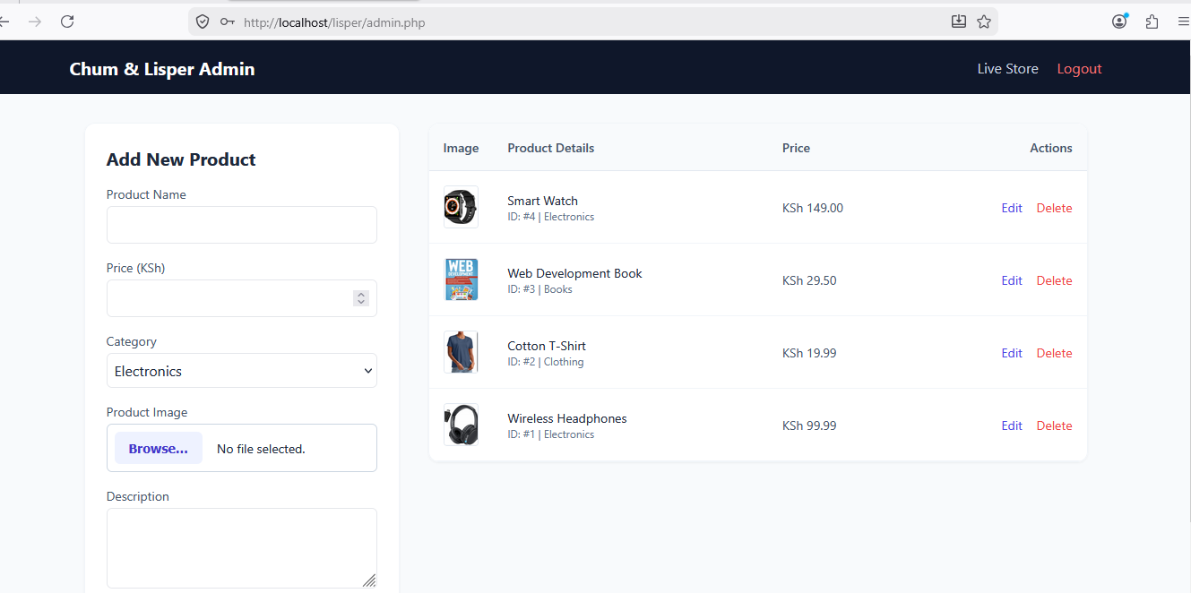

Reflection: The minimalist grid design was chosen for the Chum/Lisper store system to make browsing items clear and straightforward. To improve the user experience, I focused on reducing clutter so store admins and buyers wouldn't get overwhelmed. The navigation flow was planned to move users sequentially from selecting an item straight to the checkout page in as few clicks as possible. The system's intended users are everyday customers placing orders and store managers keeping track of stock, meaning the interface had to be simple, fast, and easy to learn.

Week 3: JavaScript and PHP Basics

Title: Frontend Interaction and Backend Foundations

Fig 1: JavaScript Form Validation
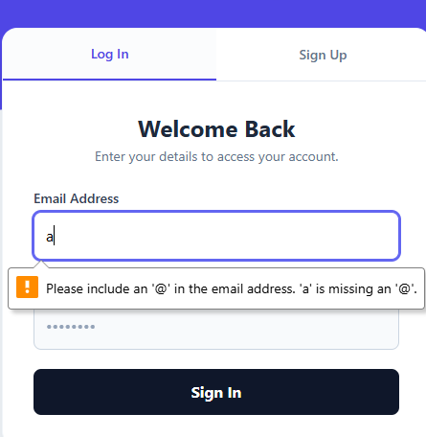

Fig 2: Password Strength Checker
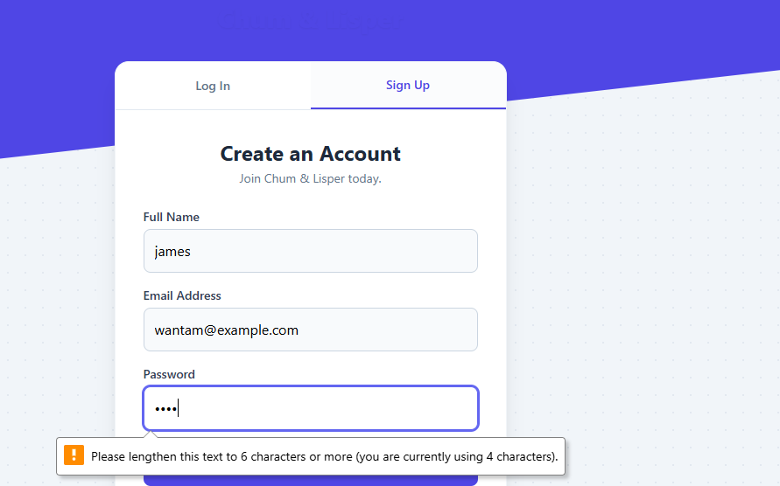

Fig 3: PHP Syntax Practice
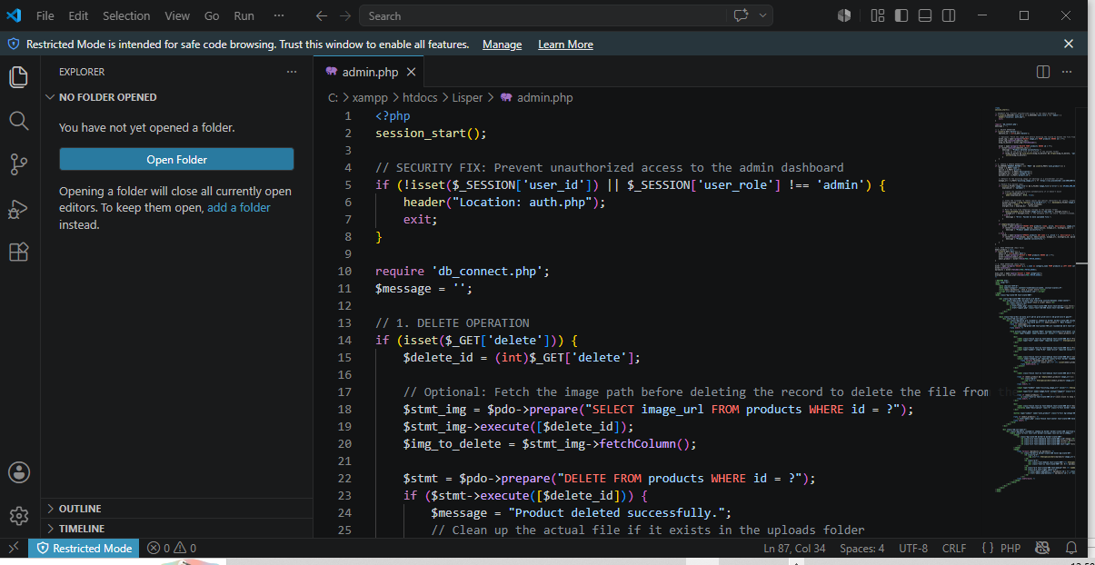

Fig 4: Database Connection Script


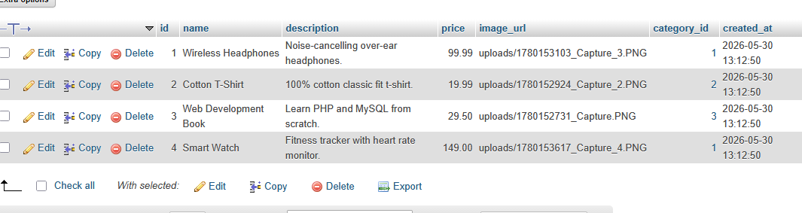

Fig 5: Dynamic User Input Handling
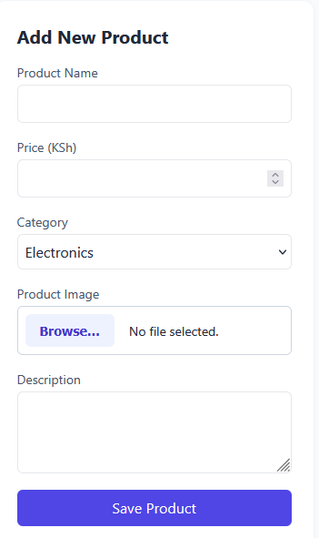
Reflection: This week involved implementing basic frontend and backend functionality for the Chum/Lisper store order-management system. JavaScript was used to validate order form inputs and prevent submission of empty fields, improving user experience before data is sent to the server. PHP was used to process order submissions and authenticate store credentials. The integration of JavaScript and PHP improved system reliability by ensuring proper data handling and validation before processing

Week 4: Dynamic Backend Processing, Authentication and Session Management

Title: System Implementation Summary

A login system was created to authenticate users before accessing the system.

Fig 1: Login System Development
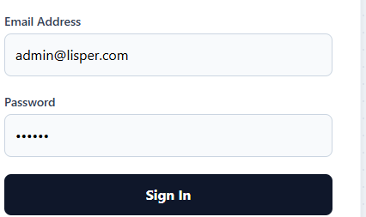

Fig 2: Login Page Interface
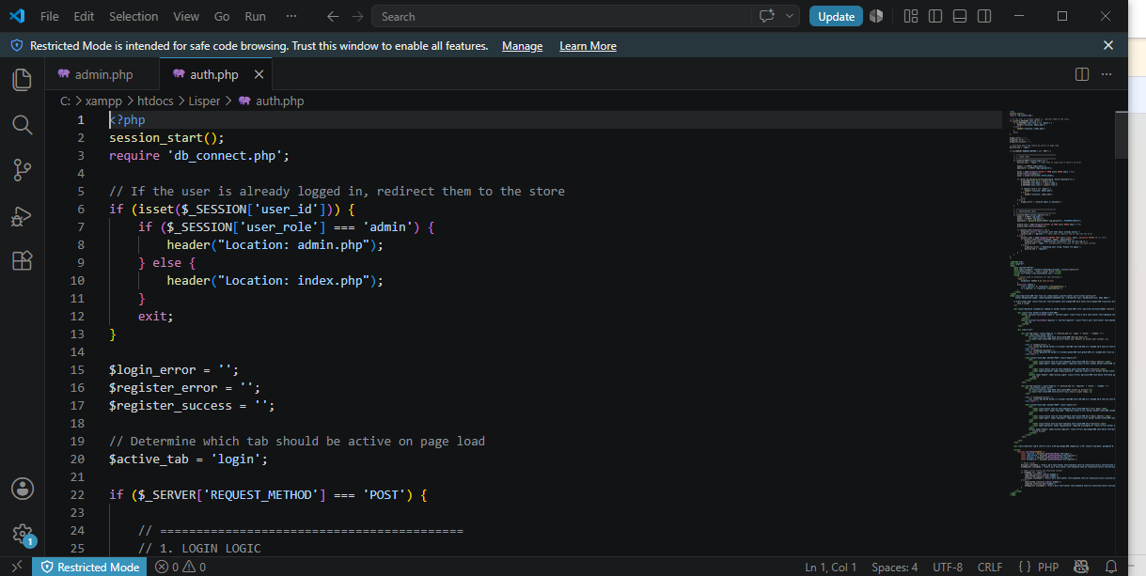

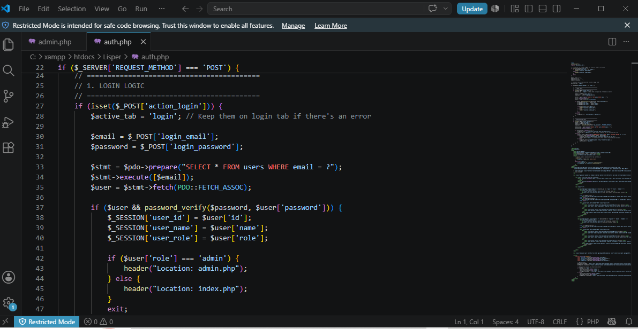

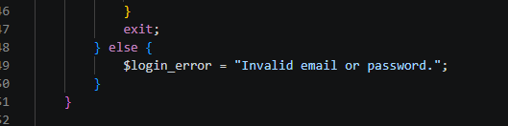

Fig 3: Database Connection Script
Users Table Created to store the user’s login details.
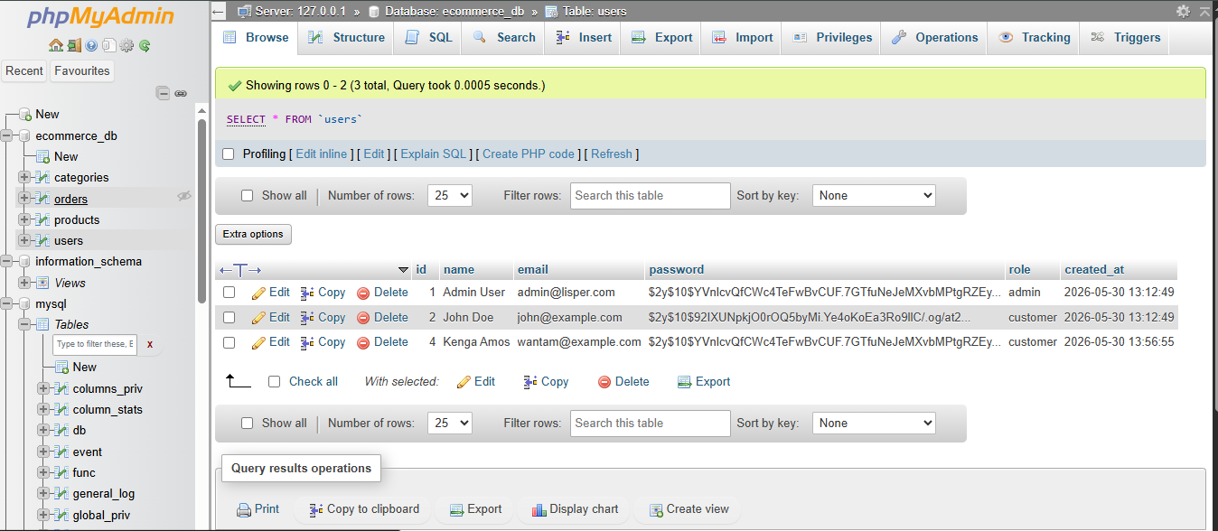

Fig 4: Users table in phpMyAdmin
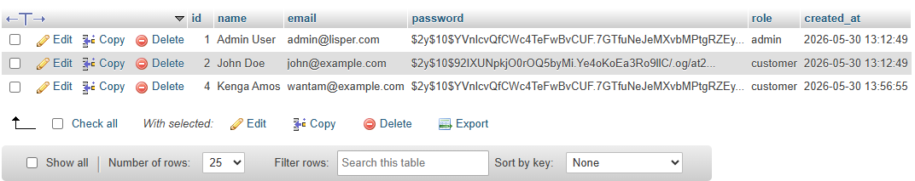

Fig 5: Session Management
To maintain user login state after successful authentication

Fig 6: Successful Login Session (Dashboard View)
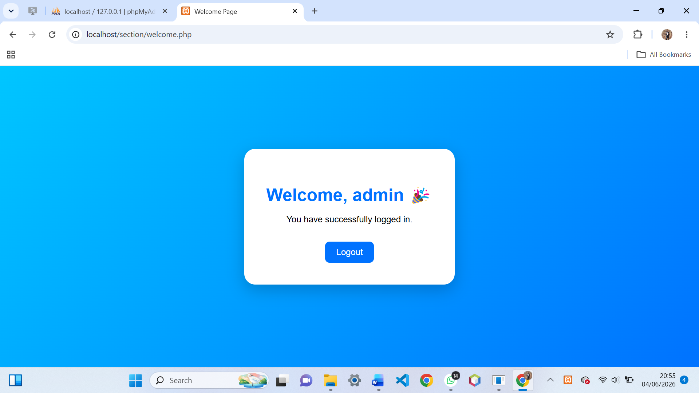

Reflection:
Week 4 focused on backend processing, authentication, and session management. A login system was successfully implemented using PHP and MySQL. Sessions were used to control access to the dashboard. Challenges included database connection errors and session handling issues which were resolved through debugging and testing.

Week 5: Building Data-Driven Systems using Databases

Task 1: Introduction to Databases

Fig 1: Php showing the database successfully created.
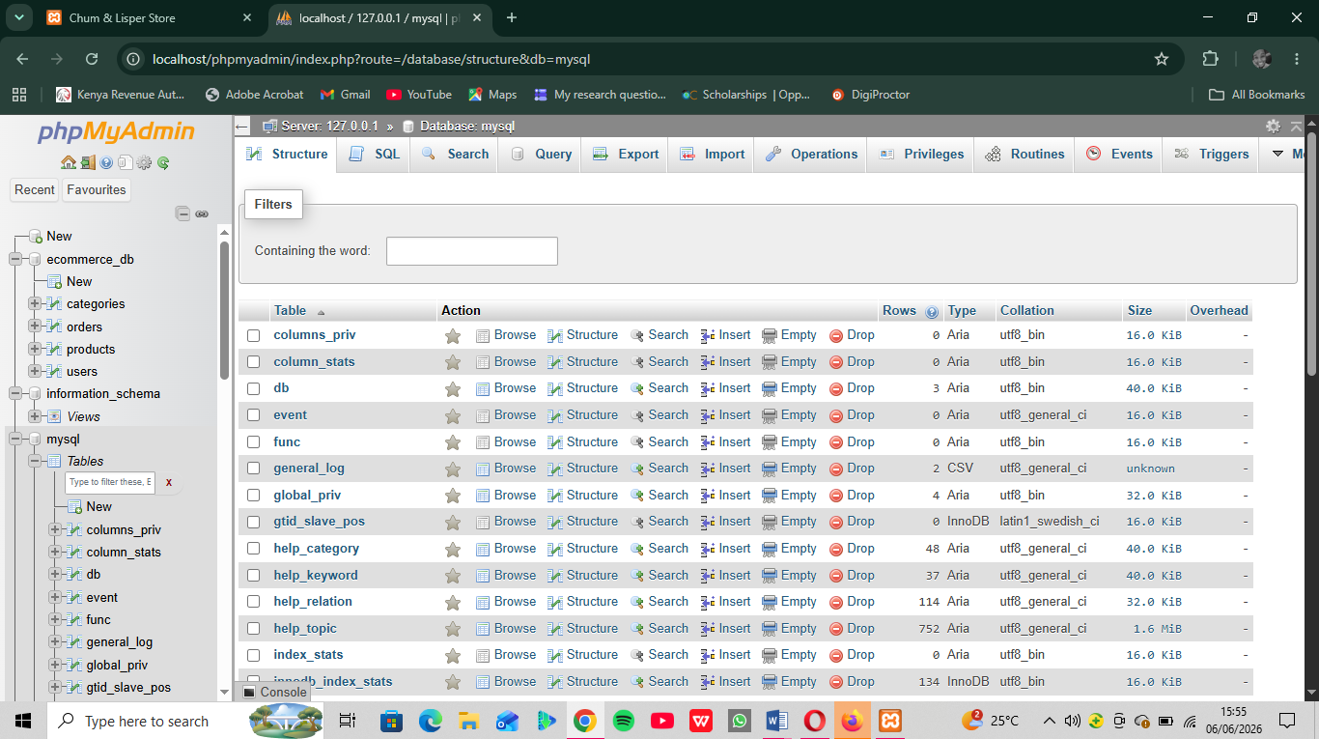

Fig 2: Table Creation for users with ID, Username, and password fields
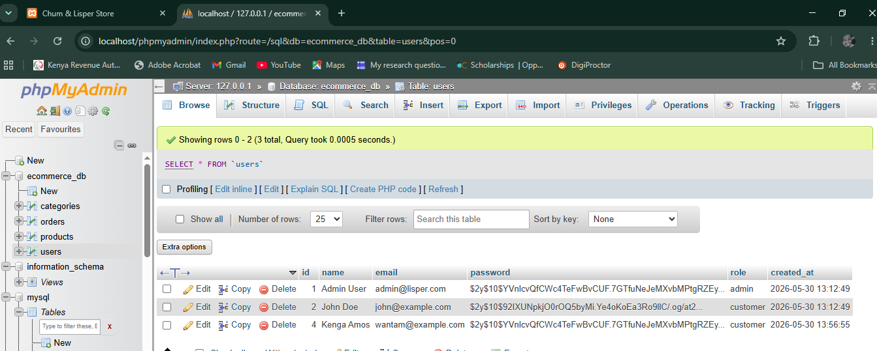

Fig 3: Insert Query adding a new customer
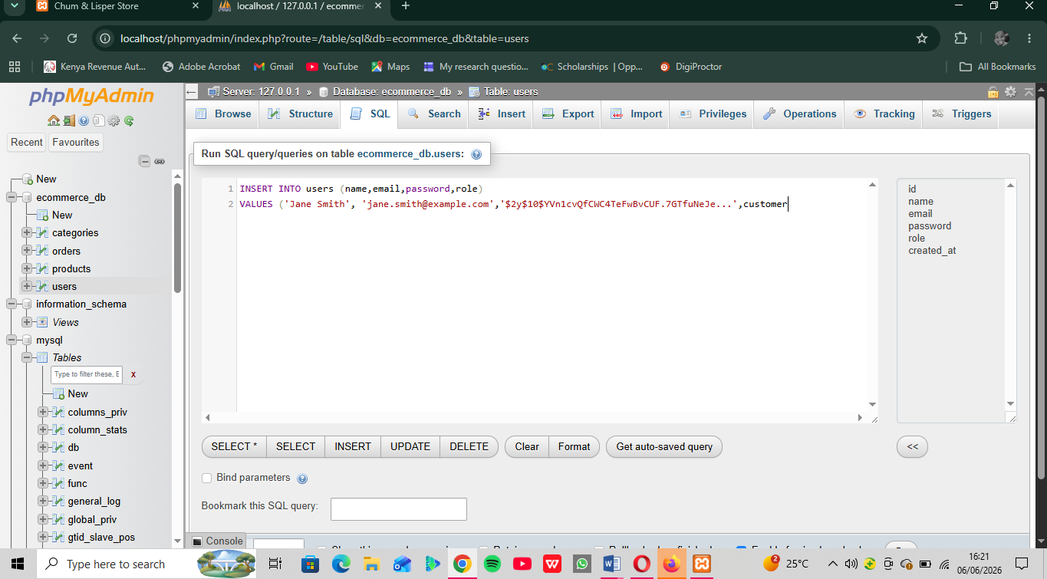

Fig 4: View records query displaying stored data
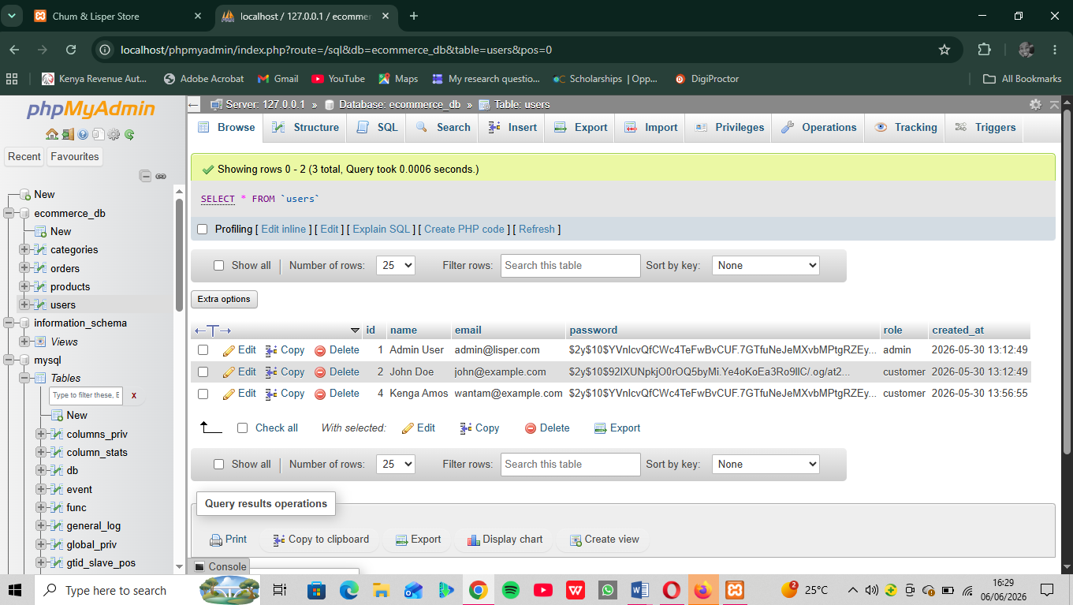
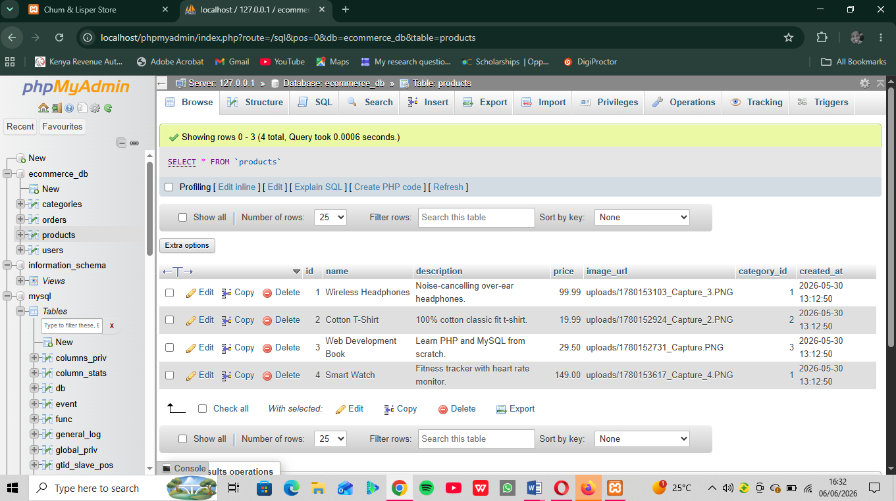

Fig 5: Edit query Updating User Information
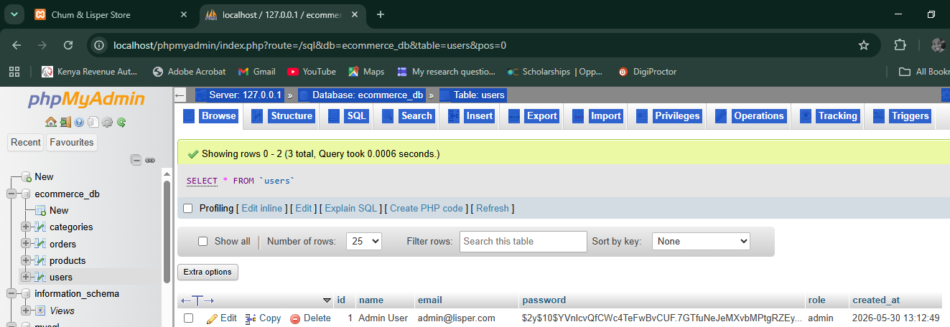
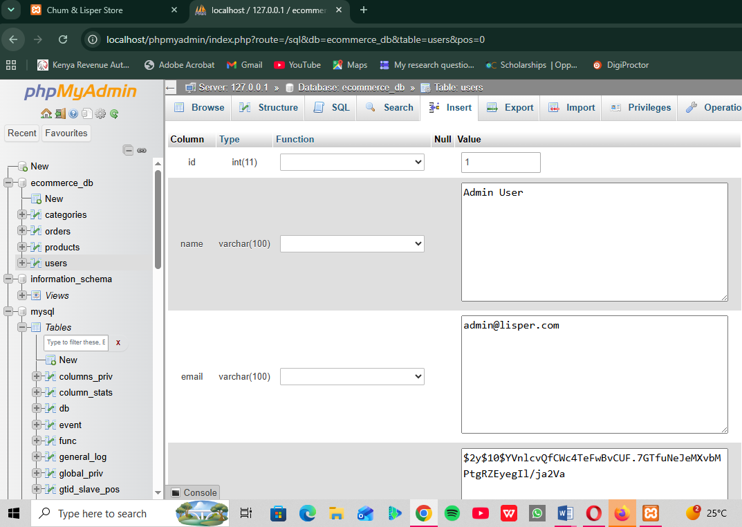

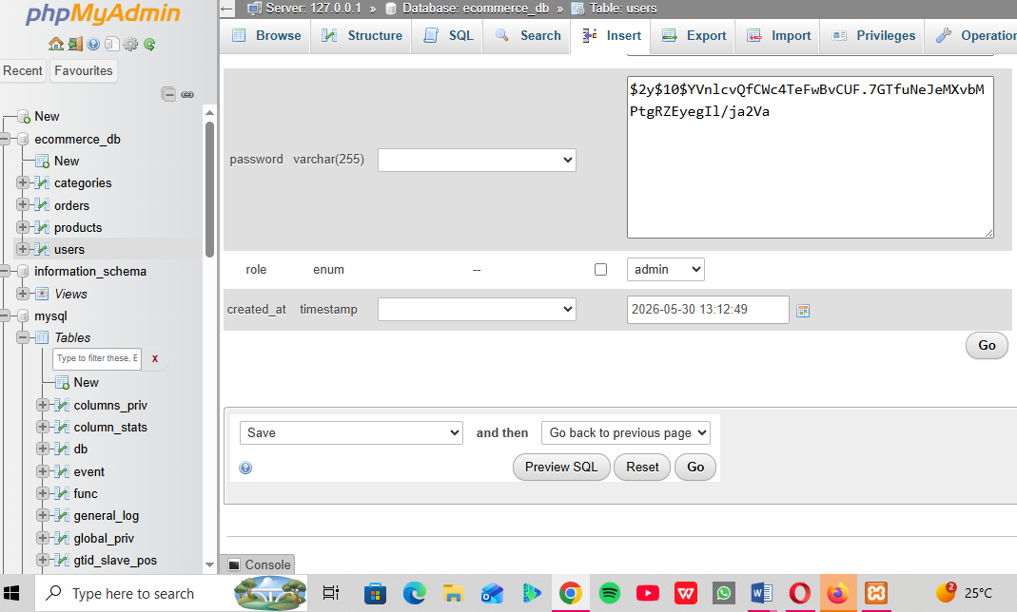

Fig 6: Delete Query Removing a record successfully (codes)

DELETE FROM users WHERE username= ‘admin’;

DELETE FROM products WHERE product name= ‘Smart Watch’;

DELETE FROM customer WHERE name= ‘Kenga Amos’;

Reflection: This week I learned how to build database-driven systems. Fig 1–3 show the creation of student, product, and authentication databases. Fig 4 demonstrates table setup for user credentials. CRUD operations (Fig 5–8) allowed me to add, view, edit, and delete records, proving full database functionality. These tasks taught me how backend systems manage persistent data and connect to frontend forms. The main challenge was ensuring queries executed correctly, which improved my understanding of SQL syntax and database integration with PHP.

WEEK 6

Task: Database Integration and CRUD functions

Fig 1: Connect to MySQL using db.php
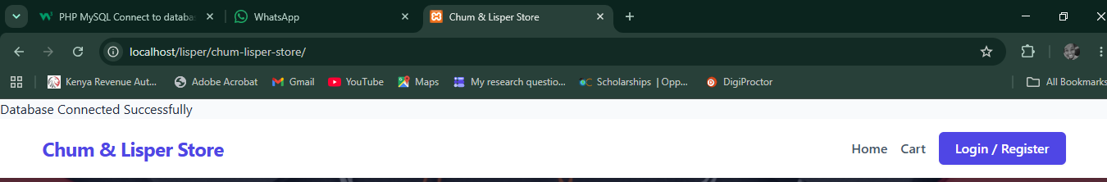

Fig 2: CREATE Operations to Insert Products Records
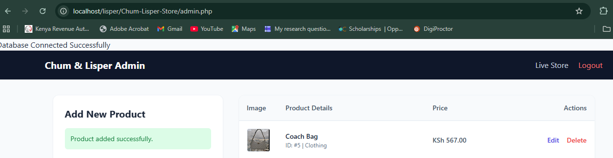

Fig 3: READ Operation to Display Products Records
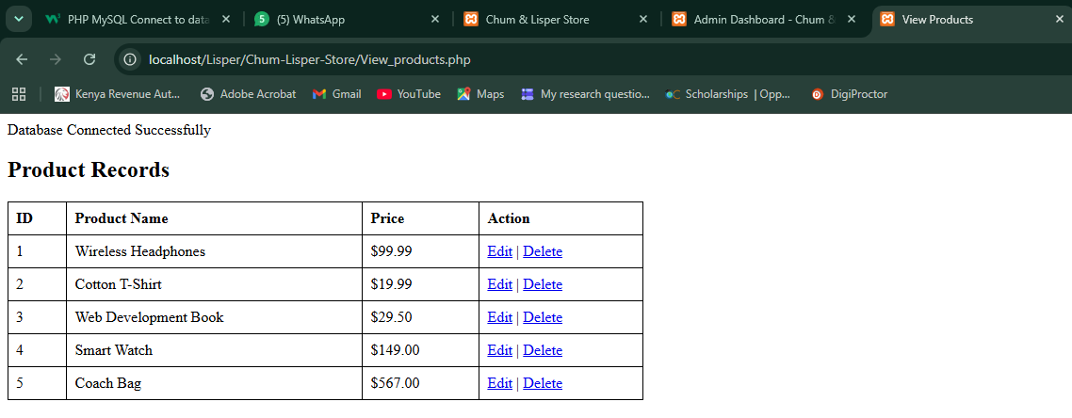

Fig 4: UPDATE Operation to edit products Records
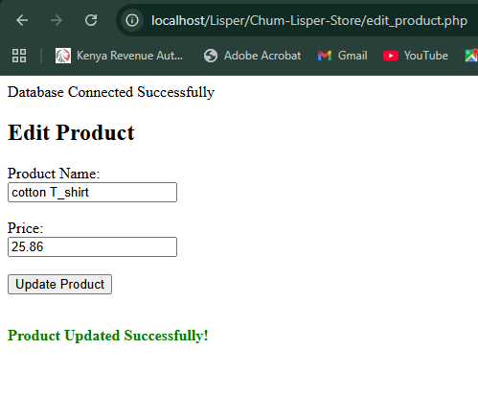

Fig 5: DELETE Operation to delete product record
